SeitenNova
Michael Stephan
Germany
Subject: Technical Inquiry Regarding the SUS Aluminium Profile System for the SNR-1 Development Project (SeitenNova Racing Rig)

Dear Sir or Madam,
My name is Michael Stephan, and I am the Managing Director of SeitenNova in Germany.
We are currently developing the SNR-1 (SeitenNova Racing Rig), a high-end professional sim racing cockpit for the international market. The first prototype is planned to be manufactured in Thailand.
For the entire structural design, we intend to use only the original SUS aluminium profile system. As our project is currently in the engineering phase, we would like to base our design entirely on your profile system from the very beginning and therefore kindly request your technical support.

Planned Use of the Aluminium Profiles
For the construction of the SNR-1, we currently plan to use the following profile sizes from your 40 mm profile system.

40 × 80 mm Aluminium Profile

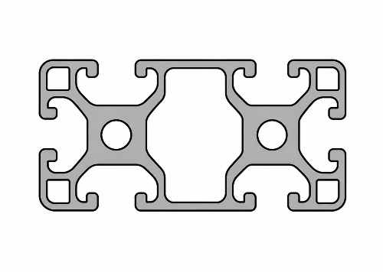
This profile will be used for all primary load-bearing components of our racing rig, including:
- Main longitudinal frame rails
- Fixed cross members
- Highly loaded structural components
(A cross-sectional drawing of the profile will be inserted at this point in the document.)
We would appreciate receiving the following information:
- Original SUS part number
- Official profile designation
- Material specification
- Surface finish
- Weight per meter
- Area moments of inertia (Ix / Iy)
- Section modulus
- Permissible load ratings
- Available standard lengths
- Availability in Thailand
If several 40 × 80 mm profile variants are available, we would appreciate your recommendation for high-load industrial and machine-frame applications.

40 × 40 mm Aluminium Profile

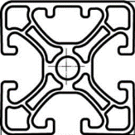
This profile will be used for all adjustable assemblies of the SNR-1, including:
- Pedal module
- Wheelbase support
- Seat module
- Accessory mounts
- Additional adjustable assemblies
We would also appreciate receiving the following information:
- Original SUS part number
- Official profile designation
- Material specification
- Surface finish
- Weight per meter
- Area moments of inertia
- Permissible load ratings
- Available standard lengths
- Availability in Thailand

Connection Technology
As the SNR-1 is being developed as a highly rigid and durable structure, we would also appreciate your recommendation regarding the most suitable connection technology.
We are particularly interested in:
- Internal connectors
- Heavy-duty internal connectors
- Angle brackets
- End connectors
- Quick connectors
- Reinforcement plates
- Any additional connection systems recommended by SUS
Please also provide the corresponding original SUS part numbers and technical specifications.

T-Slot Nuts and Fastening Components
We would also appreciate your recommendations for the appropriate components within your 40 mm profile system, including:
- T-slot nuts
- Bolts and screws
- Washers
- Threaded inserts
- End caps
- Adjustable leveling feet
- Casters
- Cable ducts / cable management components
- Any additional accessories

Technical Documentation
If available, we would appreciate receiving the following documentation:
- Current product catalogue
- CAD files (STEP, DXF and PDF)
- Technical data sheets
- Structural load data for the aluminium profiles
- Load ratings for the connection components
- Assembly instructions
- Engineering design guidelines
- Recommendations for high-load machine-frame constructions

Distribution and Availability in Thailand
As our first prototype will be manufactured in Thailand, we would also appreciate information regarding:
- Your contact person in Thailand
- Your office or authorized distributor in the Bangkok area
- Delivery times
- Stock availability
- Price lists or dealer conditions

Project Objective
Our objective is to develop a professional, modular sim racing cockpit for the international market. The complete system is intended to be based entirely on original SUS components and to serve as the foundation for future series production.
We would greatly appreciate your technical support and your recommendation of the most suitable SUS components for our application.
Thank you very much for your assistance. We look forward to your reply and to the opportunity of working with SUS on this project.
Yours sincerely,
Michael Stephan
Managing Director
SeitenNova
Germany

